PROJECT SYNOPSIS

**On**

# ANALYSIS AND CLASSIFICATION OF COPD USING



DARSHAN K K [U13XF21S0045]

GANESH M K [U13XF21S0050]

VENKATESH NAIK R [U13XF21S0051]

VENKATESH R [U13XF21S0026]

KARTHIK B V [U13XF21S0046]

**6 TH SEMESTER**

**BACHELOR OF COMPUTER APPLICATION [BCA]**

## ABSTRACT

The Chronic Obstructive Pulmonary Disease Prediction System aims to revolutionize early detection and prognosis through the integration of deep learning and health data analysis using dataset that includes X-Ray obtained from a diverse range of patients. The integration of data collected from multiple hospitals are utilized with employing Deep learning algorithm. The predictive model identifies the pattern within the data collected and identify early indicators of COPD. The COPD aims to mitigate the impact of this chronic respiratory condition. This project carries significant implications for advancing early detection of COPD using Convolutional Neural Networks (CNNs) and aspires to enhances health care efficiency.

### INTRODUCTION

Chronic Obstructive Pulmonary Disease (COPD) is a progressive lung disease characterized by obstructed airflow, leading to breathing difficulties. It includes diseases like emphysema and chronic bronchitis and is mainly brought on by continuous exposure to irritants including air pollution, dust from job environments, chemicals, and cigarette smoke. Millions of individuals worldwide suffer with COPD, which constitutes a serious global health concern that increases enormous expenditures for healthcare along with morbidity and mortality. Effective management and intervention of COPD depend on early detection and diagnosis considering the disease is frequently underdiagnosed and untreated in its earliest phases. Spirometry is a traditional method of diagnosing COPD; it measures lung function and evaluates symptoms and risk factors clinically. Nevertheless, not all healthcare environments may have easy access to these techniques, especially in positions with minimal resources or during public examinations.

With recent advancements in machine learning and deep learning techniques, there has been growing interest in leveraging artificial intelligence (AI) for medical image analysis and disease diagnosis. Convolutional Neural Networks (CNNs), a type of deep learning model, have shown remarkable performance in various image recognition tasks, including medical imaging.

In this project, we aim to develop and deploy a deep learning-based system for the detection of COPD from chest X-ray images. By harnessing the power of CNNs and transfer learning, we seek to create a robust and accurate model capable of automatically identifying signs of COPD in medical images. Our ultimate goal is to provide healthcare practitioners with a valuable tool for early COPD screening and diagnosis, potentially improving patient outcomes and reducing the burden on healthcare systems.

### PROBLEM STATEMENT

Chronic Obstructive Pulmonary Disease (COPD) presents a significant global health challenge, impacting individuals and healthcare systems. The ability to diagnose patients quickly and accurately is limited by traditional diagnostic techniques, which rely on clinical histories, patient visits, and manual analysis of images. The project provides an innovative approach for improving diagnostic analysis and classification using convolutional neural networks (CNNs) trained on X-Ray images, in order to solve the major global health concern posed by Chronic Obstructive Pulmonary Disease (COPD).

### OBJECTIVES

The main objectives of the project are:

* Extract a diverse image dataset from electronic health records, ensuring it encompasses various COPD manifestations.
* Standardize and normalize the image datasets.
* Choose Convolutional Neural Networks (CNNs) for image analysis, train the model on standardized data, and evaluate its performance using dedicated test sets and relevant metrics.

**EXISTING SYSTEM & PROPOSED SYSTEM :**

**EXISTING SYSTEM :** The process of diagnosing Chronic Obstructive Pulmonary Disease (COPD) entails a comprehensive assessment that includes diagnostic tests, medical history, and clinical assessment. The first steps involve a thorough physical examination and the collection of specific information on symptoms, smoking history, and family medical history. Spirometry is one of the most important pulmonary function tests (PFTs) used to evaluate lung function. Extra resources such as high-resolution CT scans, arterial blood gas (ABG) measurement, provide more information. Testing for bronchodilator flexibility is commonly part of the diagnostic refinement process. With the help of classification systems such as the Global Initiative for Chronic Obstructive Lung Disease (GOLD), specific remedies can be implemented. In order to ensure that COPD patients receive complete care, consulting with healthcare specialists is crucial for accurate diagnosis and the creation of individualized treatment programs.

**PROPOSED SYSTEM :** The proposed method uses deep learning, specifically convolutional neural networks (CNNs), to transform the diagnosis of Chronic Obstructive Pulmonary Disease (COPD), and a major global health concern. To guarantee accurate results, the study makes use of X-Ray from both affected and unaffected patients. The carefully developed architecture is systematically trained to identify complex patterns linked to COPD severity levels, making use of learned features from previously trained models to improve efficiency and avoid over fitting. When compared to human methods, the model's ability to enable automatic image evaluation greatly reduces diagnosis time once it has been trained. Improvements to changing patterns of COPD are driven by ongoing monitoring, assessment, and input from healthcare experts. In order to ensure responsible system development and promote safe artificial intelligence use in healthcare management.

**SYSTEM REQUIREMENTS :**

### HARDWARE REQUIREMENTS

Programming-language: Python

Libraries: Tensor Flow, Scikit – Learn, Open CV

IDE: Jupiter Notebook

### SOFTWARE REQUIREMENTS

Processor: Intel Core i3

RAM: 6GB

Hard disk: 500 GB

### 

### SYSTEM DESIGN

The Chronic Obstructive Pulmonary Disease (COPD) Prediction System leverages the convergence of deep learning and health data analytics to provide an approach to revolutionizing early detection. Through the utilization of an extensive dataset that include X-Ray images obtained from various patient in various healthcare facilities, this system aims to transform the diagnosis and treatment of COPD. Fundamentally, the system incorporates cutting-edge deep learning algorithms, such as Convolutional Neural Networks (CNNs), to identify early markers of COPD and extract complex patterns from the collected data. By collecting data from different populations and clinical presentations, the prediction model attempts to identify important indicators of COPD development or progression.

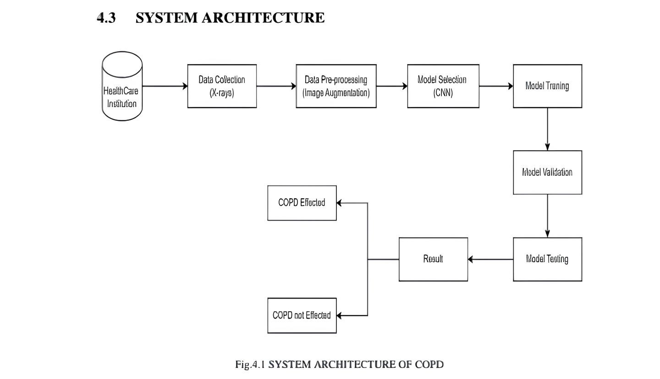

### 

### PRO’S of COPD

1. **Early Detection:** The project's main benefit is its ability to identify COPD

early. Early diagnosis enables prompt intervention and treatment, which may enhance patient outcomes and slow the disease's course.

1. **Better Prognosis:** The system may offer more precise information by

using deep learning algorithms to evaluate a variety of health data, including X-Ray images. This helps to enhance patient outcomes and quality of life.

1. **Efficiency:** By combining data from hospitals, which helps raise the

prediction model's accuracy. Furthermore, the diagnosis process can be made more scalable and effective by automating the examination of massive amounts of medical pictures by utilizing deep learning techniques like

Convolutional Neural Networks (CNNs).

**4.** **Personalized Medicine:** The prediction model may be able to reveal minute differences in the way a disease presents and advances among various patient groups by finding patterns in the data that has been gathered. This makes it possible to provide healthcare in a more individualized manner, adjusting treatments to meet the needs and preferences of each unique patient.

**CON’S of COPD**

1. **Data Security and Privacy Issues:** Data security and patient privacy are issues that are brought up by the integration of data from several hospitals.
2. **Bias in Data:** The representativeness and quality of the training dataset have a major impact on the accuracy of the predictive model. Healthcare disparities may result from the model's incorrect predictions if the dataset is skewed or unrepresentative of the general population.
3. **Difficulties with Integration:** Due to variations in data formats, storage systems, and data-sharing protocols, integrating data from several hospitals and healthcare systems can be technically difficult.

### CONCLUSION

In conclusion, the project highlights how Convolutional Neural Networks (CNNs) hold promise for accurately diagnosing COPD from chest X-ray images, achieving impressive accuracy through optimized architectures and preprocessing methods. The reliability of approach is underscored by robust evaluation metrics, while interpretability techniques offer valuable insights for healthcare providers. This integration of deep learning and medical imaging offers a compelling pathway toward transforming COPD diagnosis and patient care.

### Looking into the future of COPD prediction systems

Looking into the future of COPD prediction systems, several advancements and trends could shape their analytics:

1. **Precision Medicine**: As our understanding of COPD heterogeneity grows, future prediction systems may incorporate more personalized data, such as genomic information, biomarkers, and environmental exposures, to tailor risk assessments and interventions to individual patients.
2. **Integration of Wearable Technology**: Wearable devices capable of continuously monitoring vital signs, lung function, physical activity, and environmental exposures could provide rich streams of data for COPD prediction systems, enabling real-time monitoring and early detection of exacerbations or disease progression.
3. **Big Data and AI**: With the increasing availability of healthcare data, including electronic health records, imaging studies, and genetic information, advanced AI algorithms, including deep learning, may be employed to extract meaningful insights and improve the accuracy of COPD risk prediction models.
4. **Predictive Analytics for Healthcare Systems**: Healthcare systems could leverage predictive analytics to forecast COPDrelated healthcare utilization, resource needs, and patient outcomes, facilitating proactive resource allocation, care planning, and population health management.
5. **Longitudinal Monitoring and Dynamic Risk Prediction**: Future COPD prediction systems may adopt longitudinal monitoring approaches, continuously updating risk assessments based on evolving patient data and enabling dynamic adjustments of preventive strategies and treatment plans.